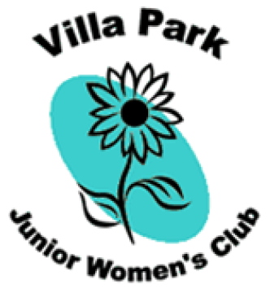
The Villa Park Junior Women’s Club Scholarship
The Villa Park Junior Women’s Club is sponsoring a scholarship program to benefit two female Villa Park high school seniors. The purpose of this scholarship is to promote and reward the involvement of women in a variety of community service activities.
A $1500 scholarship and a $500 scholarship will be awarded at the Senior Awards Night(s) at the recipients’ high school(s) in the Spring. The scholarships will be based on the application and recommendations received. These scholarships are not awarded based on financial need.

Qualifications:
- Be a current female resident of Villa Park, Illinois. The recipient’s social security number will need to be provided in order to accept the award.
- Have high school senior status.
- Maintain a minimum cumulative grade point average of 3.0/4.0 or equivalent (depending on scale).
- Have participated in a minimum of one (1) community service activity for a minimum of two (2) years. (This includes the current semester of application).
- Obtain two letters of recommendation excluding family members.

Application and recommendations must be received by April 15, 2016 to one of the following:
- Villa Park Junior Women’s Club Scholarship, P.O. Box 6232, Villa Park, IL 60181
- Online at: http://www.vpjwc.org

Name _____________________________________________________________________
Email address ______________________________________________________________
Phone number _____________________________________________________________
Home address ______________________________________________________________
Grade Point Average __________________/4.0 or ____________________________ /5.0
On a separate sheet(s) of paper, please type your responses to the following:
(not to exceed 2 pages total)
1. Describe your post-graduation goals.
2. List your community service activities. Include the name of the activity, the dates participated, the name of the sponsor and a phone number to contact the sponsor.
3. Briefly describe some of your reasons for participating in the community service projects that you indicated above. Did/Do you feel that you made a difference? Why?

I certify that the information provided on this application is accurate.
__________________________________________________________________________
Signature of Applicant Date
__________________________________________________________________________
Signature of Parent/Guardian Date

